Experiment No. 8

Title:
Form Handling and Event-Based Validation using JavaScript

Software / Tools Required:
- Visual Studio Code (VS Code)
- Google Chrome (Browser)

Theory:
This experiment explores form handling, form field access, event handling, and real-time input validation using JavaScript. The Gym Admission Portal demonstrates how JavaScript can interact with HTML form elements and provide immediate feedback to users. The core theoretical concepts implemented include:
- Form Field Access: JavaScript accesses different form elements using methods such as document.getElementById() and retrieves their values through the .value property.
- Event Handling: JavaScript event listeners are used to respond to user interactions such as input, change, and submit. The input event provides real-time validation while the change event responds to changes in selected options.
- Live Input Validation: The application validates fields while the user enters information. The name, email address, mobile number, age, membership plan, and time slot are checked according to their required conditions.
- Email Validation: JavaScript checks whether the entered email follows a valid email format before allowing the form to be submitted.
- Form Submission: The submit event is handled using JavaScript to validate the complete form before processing the admission. The default form submission behaviour can be controlled using preventDefault().
- Dynamic DOM Updates: Validation messages, completion status, and membership preview are updated dynamically using DOM properties and methods. This allows the interface to immediately reflect the user's entered information.
- Conditional Validation States: The interface displays appropriate valid or invalid states for individual fields. Once all required fields are correctly completed, the form displays a successful admission confirmation.
- Interactive User Feedback: After successful validation, an Admission Successful confirmation is displayed containing details such as registration ID, applicant name, email, mobile number, age, membership plan, and selected time slot.

AIM OF THE CASE STUDY :
To design and develop a Gym Admission Portal using JavaScript that handles form input, performs real-time event-based validation of user details, dynamically updates the interface, and displays an admission confirmation on successful submission.
Name : Parth Dhoke
PRN : 24070521257

Output :
The Gym Admission Portal webpage was successfully displayed. It validates the name, email address, mobile number, age, membership plan, and time slot in real time, updates the validation messages and membership preview dynamically, and displays an Admission Successful confirmation with the registration details once all fields are valid.
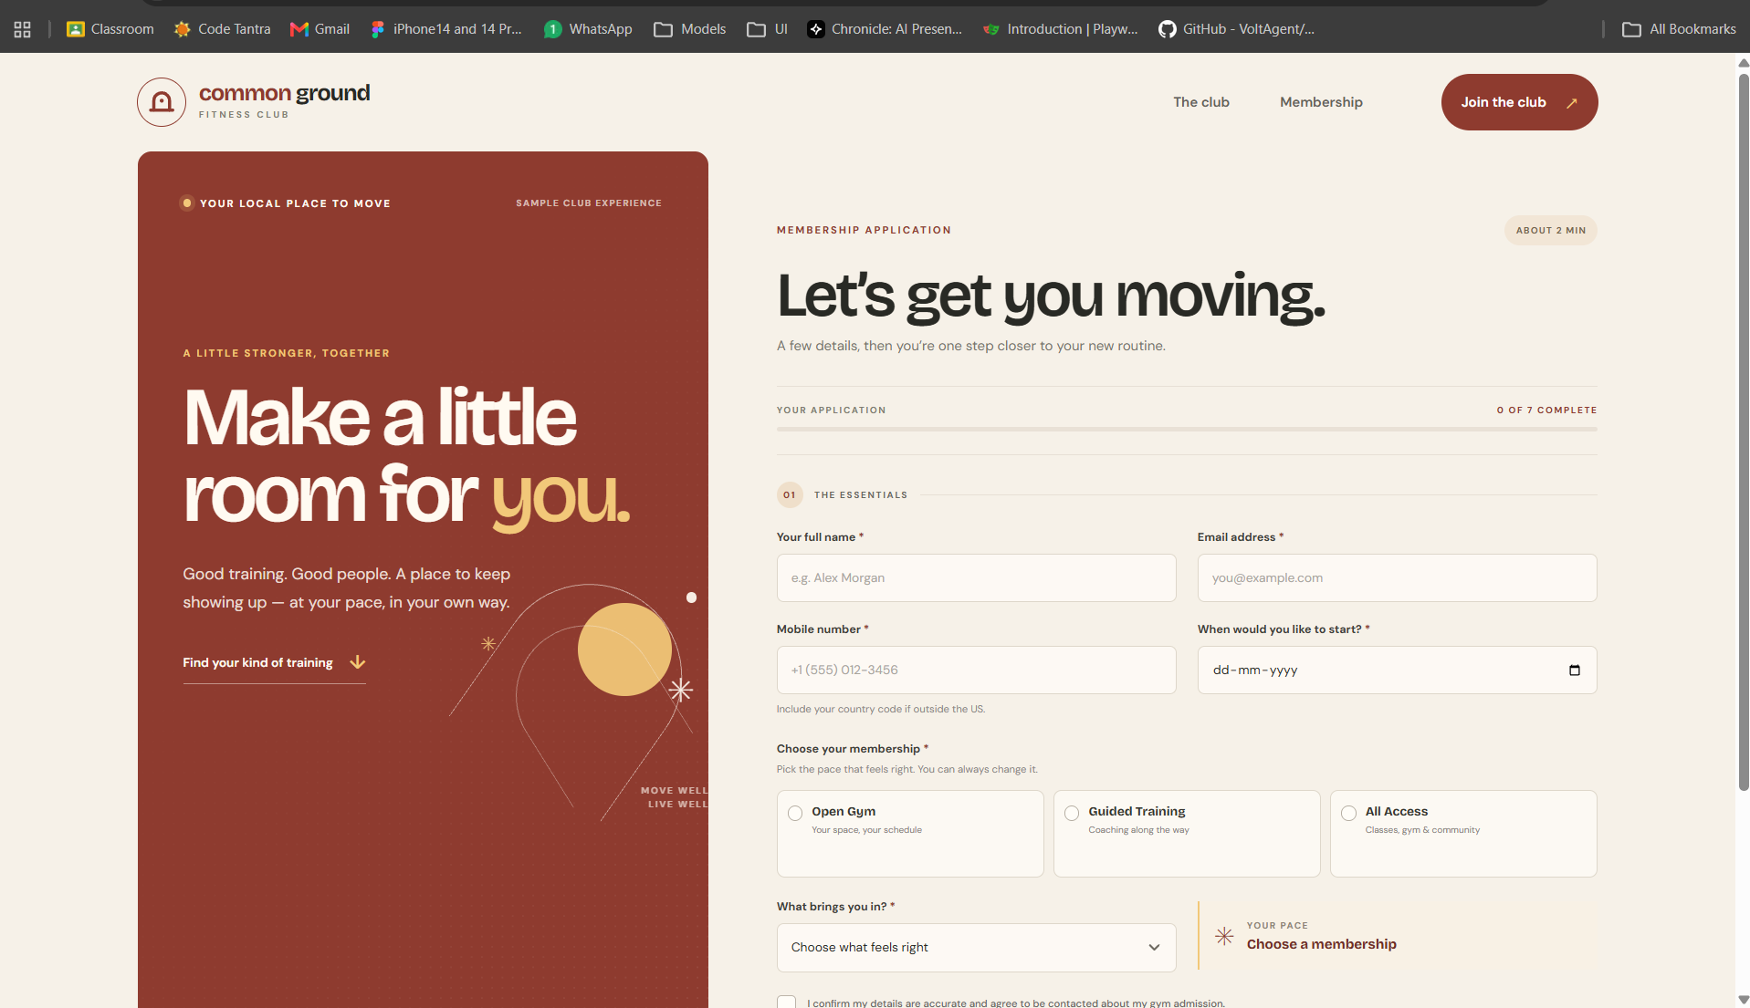

Result / Conclusion:
In conclusion, this experiment demonstrated form handling and event-based validation using JavaScript by developing a functional Gym Admission Portal. The application successfully accessed form fields, handled input, change, and submit events, performed real-time validation, and dynamically updated the user interface. The successful admission popup confirmed that the entered information was correctly validated and processed. Thus, the experiment demonstrated effective use of JavaScript events, DOM manipulation, and form validation in an interactive web application

